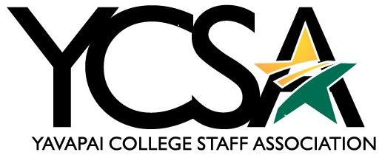

Date May 9th, 2024

Agenda
General Meeting
Zoom link: https://yavapai.zoom.us/j/7848133843
12-1 pm
College Council and College Council Committees update
Julie Galgano
  - College Council 2.0- Did not meet and done for fiscal year.
  - Budget- 3% for all, 1% retention bonus. Voting on the budget on May 21st.
  - Staff Professional Development Day
  - Meetings in person-YCSA on Thursdays 8:00am followed by training. Four topics finance, stress management, management. Training will be following the YCSA meeting with breakfast, and mileage reimbursement. YCSA meeting will be Zoom before these trainings. Starting July 1st, meeting in 3-119. Schedule of meetings will be coming out in the YCSA newsletter. One Zoom link that will be sent out. Any staff member can attend YCSA meetings. If they are off campus they will be reimbursed and do not need to make up time for attending.
  - Clubs- Tonya Nolan presented the idea of having staff clubs, volunteer 8 hours a year go out into the community, webpage different types of clubs hiking, book, volunteering. We don’t have staff clubs to get to know each other. (Attached is the summary of ideas) Get together with employees and help the community.
  - Gwen Payne- Winter Celebration, and food box donations- Find ways to create funding for food boxes. Last year that got a gift card for their choice of meat. This year we will be asking employees to help donate to get those gift cards for the holiday boxes. They are working with Manzanita Outreach to get food donations. In need $2,000 to get purchase gift cards. Last year were 49 boxes this year is estimated to be double. Possibly Christmas in July for canned food for the Christmas boxes.
  - Our last meeting-new schedule
  - Professional development day is still TBD. Sometime during the Fall and in-person unsure of location.
Leslie Sparkman-Absent
  - Policy Review
Deanna Mooney
  - Staff Professional Growth
Katherine Anderson-Absent
  - Elections
  - Newsletter
Janet Nix
  - ELT Update- 15 out of state workers, when we have commencement/convocation. When they come to the college pay for it. Require remote employees for their own payment of travel.
  - Hold on backfills for new hires 30-45 days. To get the raises that we want.
  - Internal candidates over open pool to the public for the first 5 days-HR happenings “New Openings”
  - Orientation- Monday two days a month with HR Brittany Hollar.

Executive Board Meeting:
1pm-2pm
  - Retreat

  - Zoom Link for entire year

